Jonathan Nicolosi

CS 325-400 Summer 16

Homework Assignment 1

We want to find where 8n2 = 64n lg n. This reduces to n = 8 lg n.

|  |  |
| --- | --- |
| n | 8lg(n) |
| 1 | 0 |
| 2 | 8 |
| 4 | 16 |
| 8 | 24 |
| 16 | 32 |
| 32 | 40 |
| 64 | 48 |

We can see from this table that insertion sort beats merge sort for all values of n below 32, and for values of n above 64 merge sort beats insertion sort. Evaluating the functions for n in the interval (32, 64), we find that for all values of n < 44 insertion sort beats merge sort.

|  |  |  |  |  |  |  |  |
| --- | --- | --- | --- | --- | --- | --- | --- |
|  | 1 second | 1 minute | 1 hour | 1 day | 1 month | 1 year | 1 century |
| lg n | 21,000,000 | 260,000,000 | 2360,000,000 | 28,640,000,000 | 2259,200,000,000 | 294,608,000,000,000 | 29,460,800,000,000,000 |
|  | 1x1012 | 3.6x1015 | 1.30E+17 | 7.46E+19 | 6.72E+22 | 8.95E+27 | 8.95E+31 |
| n | 1,000,000 | 60,000,000 | 360,000,000 | 8,640,000,000 | 259,200,000,000 | 94,608,000,000,000 | 9.46E+15 |
| n lg n | 62746.1 | 2.80142×10^6 | 1.50958×10^7 | 3.06479×10^8 | 7.88410×10^9 | 2.30374×10^12 | 1.99171×10^14 |
| n2 | 1000 | 7745.966692 | 18973.66596 | 92951.60031 | 509116.8825 | 9726664.382 | 97266643.82 |
| n3 | 100 | 391.486 | 711.37 | 2051.97 | 6375.95 | 45566.17 | 211499.47 |
| 2n | 19.932 | 25.838 | 28.423 | 33.008 | 37.915 | 46.427 | 53.071 |
| n! | 9 | 11 | 12 | 14 | 15 | 16 | 17 |

3.

Base Step:

If n = 2, then T(2) = 2 and 2lg2 = 2

Thus, T(2) = 2lg2

Hypothesis Step:

Assuming T(n) = nlgn is true if n = 2k for some integer k > 0

Induction step:

If n = 2k+1, then

T(2k+1)

= 2T(2k+1/2) + 2k+1

= 2T(2k) + 2k+1

= 2(2klg(2k)) + 2k+1

= 2k+1((lg(2k))+1)

= 2k+1lg(2k+1)

4.

a. O(g(n)) because f(n) grows faster

b. Ω(g(n)) because g(n) grows faster

c. O(g(n)) and Ω(g(n)) so therefore also $Θ$ (g(n)) because log10(n) = (

d. Ω(g(n)) because f(n) always grows faster

e. O(g(n)) and $Θ$ (g(n)) because there exists a k1 and a k2 that will cause f(n) to be tightly bound.

f. O(g(n)) because f(n) is bound above by g(n)

g. O(g(n))

h. Ω(g(n))

5.

First sort the list using an algorithm like Merge Sort that sorts in n time. Then perform a binary search on the sorted list.

SortedArray = {12, 3, 4, 15, 11, 7};

int i = 0;

int j = 5;

while(i<j){

if(SortedArray[i]+SortedArray[j] == 20){

return true; //found a pair

}

else if(SortedArray[i]+SortedArray[j] > 20){

j--;

}

Else

i++;

}

return false; //pair does not exist

6.

a.

Let f1(n) = O(g1(n)) and f2(n) = O(g2(n)). This means that there exist constants c1, c2 > 0 such that f1(n) ≤ c1g1(n) and f2(n) ≤ c2g2(n) for all n > 0 integers. To prove the claim, we must find some constant c3 that causes f1(n)+f2(n) ≤ c3 [g1(n) + g2(n)] for all n > 0 integers.

f1(n) + f2(n) ≤ c1g1(n) + c2g2(n)

≤ max(c1, c2)g1(n) + max(c1, c2)g2(n)

≤ max(c1, c2) [g1(n) + g2(n)]

= c3 [g1(n) + g2(n)]

We’ve found a c3 = max(c1, c2) that satisfies the definition of big-Oh, proving the claim.

b.

This is true. If there exists a constant such that f1(n) will always lie below and to the right of c*g1(n) and there exists a constant such that f2(n) will always lie below and to the right of cg2(n), then there must be a constant that we can multiply with $\frac{g1(n)}{g2(n)}$ such that $\frac{f1(n)}{f2(n)}$ will always lie below and to the right of it.

c.

This means that there exists positive constants c1, c2, and n0 such that,

0 c1(f1(n) + f2(n)) max(f1(n), f2(n)) c2(f1(n) + f2(n)) for all n n0

Selecting c2 = 1 clearly shows the third inequality since the maximum must be smaller than the sum. C1 should be selected as ½, since the maximum is always greater than the weighted average of f1(n) and f2(n).

7.

a.

unsigned long long int fibRecursive(int n){

if(n==0){

return 0;

}

else if(n==1){

return 1;

}

else{

return fibRecursive(n-1) + fibRecursive(n-2);

}

}

unsigned long long int fibIterative(int n){

int fib = 0;

int a = 1;

int t = 0;

int k;

for(k = 0 ; k<n; k++){

t = fib + a;

a = fib;

fib = t;

}

return fib;

}

b.

|  |  |  |
| --- | --- | --- |
| N | Iterative Fibonacci | Recursive Fibonacci |
| 10 | 0 | 0 |
| 20 | 0 | 0 |
| 30 | 0 | 0 |
| 40 | 0 | .833 |
| 50 | 0 | 102.888 |
| 100 | 0 | Indeterminate |
| 1,000 | 0 | Indeterminate |
| 10,000 | 0 | Indeterminate |
| 100,000 | 0 | Indeterminate |
| 1,000,000 | 0 | Indeterminate |
| 10,000,000 | .053 | Indeterminate |
| 100,000,000 | .413 | Indeterminate |
| 1,000,000,000 | 3.99 | Indeterminate |

c.

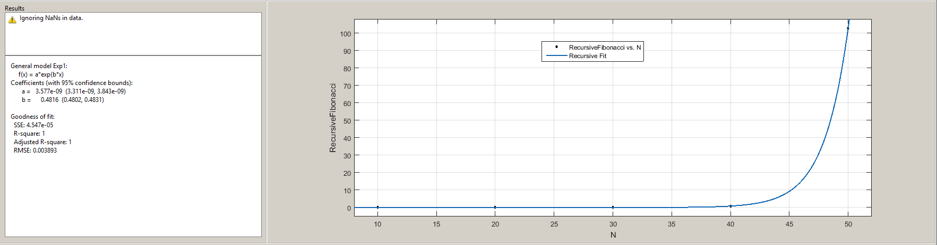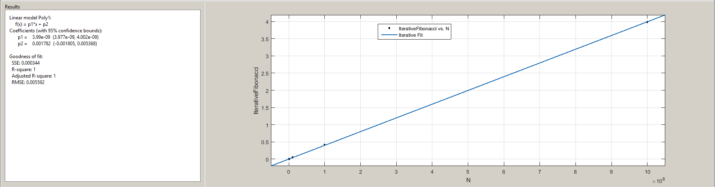

d.

The recursive Fibonacci is best fit by an exponential function:

f(x) = a*exp(b*x) where

a = 3.577e-09 (3.311e-09, 3.843e-09)

b = .4816 (.4802, .4831)

The iterative Fibonacci is best fit by a polynomial function:

f(x) = p1*x + p2 where

p1 = 3.99e-09 (3.977e-09, 4.002e-09)

p2 = .001782 (-.001805, .005368)

Recursive Fibonacci is much slower because you are adding redundant calls by recalculating the same values over and over again.